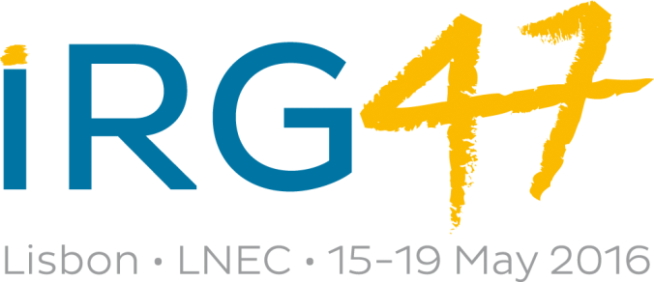

Conference Registration Form for Delegates and Companions

DELEGATE INFORMATION
Name (required) |  |  |  |  |  | Title  (Mr, Mrs, Dr, etc)
Organization
Address
City |  |  | Zip/Post Code
State |  |  | Country
E-mail |  |  | Phone

ACCOMPANYING ADULTS AND/OR CHILDREN
Name(s) |  |  |  | Relationship
CONFERENCE FEES
 |  | Fees |  | Your Payment
Member |  | SEK 5 200 |  |  |  |  |  |  | SEK
Corresponding member |  | SEK 2 500 |  |  |  |  |  |  | SEK
Student member |  | SEK 1 500 |  |  |  |  |  |  | SEK
Sponsor (person from IRG Regular and IRG47 local sponsor) |  | SEK 5 200 |  |  |  |  |  |  | SEK
Non Member |  | SEK 7 400 |  |  |  |  |  |  | SEK
Student non-member |  | SEK 2 500 |  |  |  |  |  |  | SEK
Companion (family member -15 years old or older - not  attending conference sessions) |  | SEK 1 700 |  |  |  |  |  |  | SEK
Late registration (add if you register after April 30 2016) |  | SEK 500 |  |  |  |  |  |  | SEK
Companions Tour Monday 16 May |  | SEK 1 000 |  |  |  |  |  |  | SEK
Companions Tour Tuesday 17 May |  | SEK 1 000 |  |  |  |  |  |  | SEK
Companions Tour Thursday 19 May |  | SEK 700 |  |  |  |  |  |  | SEK
Total fee to be paid to the IRG Secretariat |  |  |  |  |  |  |  |  | SEK

Method of Payment
Bank Transfer to Svenska Handelsbanken (see Money Transfer Details)
Cheque in SEK made payable to the IRG Secretariat
Visa or Mastercard (tick one)
Card No
Name of Card Holder
(as written on the card)
Expiration Date (month/year) |  |  |  | Total amount |  | SEK
Signature of
Card Holder
Money Transfer Details
Bank account Svenska Handelsbanken
IBAN No: SE 79 6000 0000 0003 9515 4421
BIC: HANDSESS
Address:
Svenska Handelsbanken
Box 26078
SE-100 41 Stockholm
SWEDEN

Please complete in CAPITALS and return before 15 April to:

IRG Secretariat
Box 5609
SE-114 86 Stockholm
SWEDEN
E-mail: irg@sp.se

For any further information please contact Mr Jöran Jermer, IRG Secretary-General
(Tel: +46 70 510 29 17, E-mail: joran.jermer@sp.se).

